CST 2309 HW 3

Refer to Tutorial 2: Create a Website for a Fitness Club

1. Complete Session 2.3 from pages HTML 138 to HTML 159

Add a screenshot of the **tss_home.html** file displayed in a browser after completing Step 4 on page HTML 158. Include the address bar in the screenshot. See Figure 2-52 for reference.

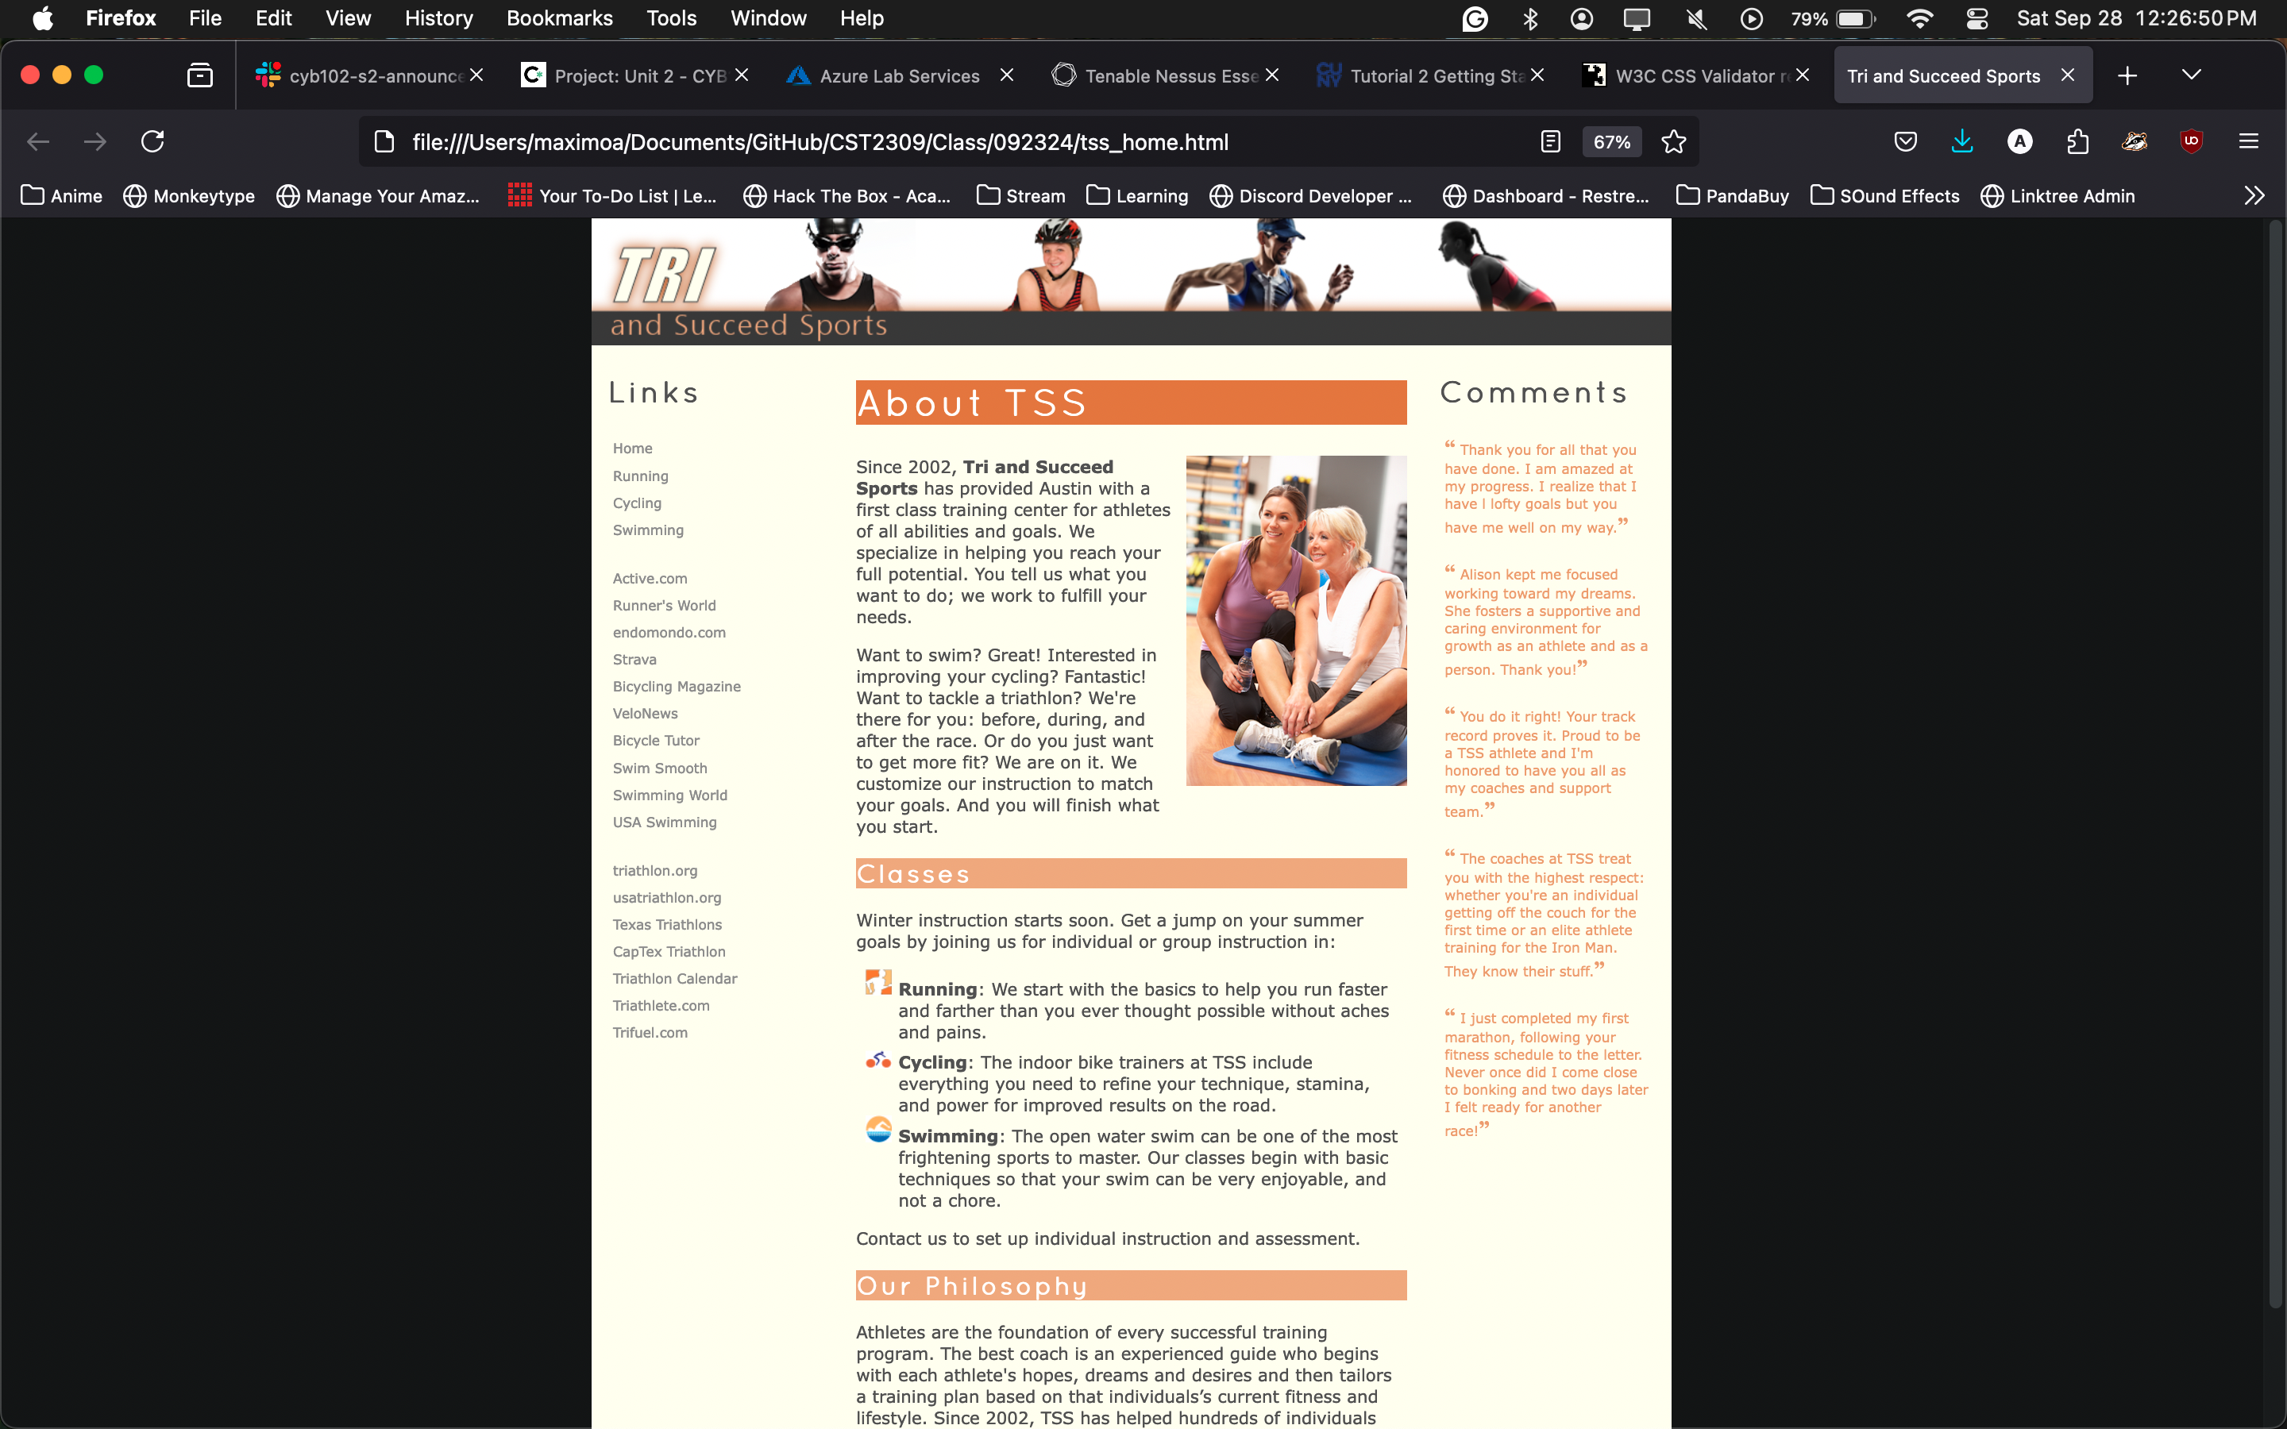

1. Publish the Fitness Club Website on Netlify
2. Add the URL of the published site in the Submission Comment Section in Blackboard
3. Complete the Session 2.3 Quick Check in Blackboard